TASK 1

Configure AWS CLI in Ubuntu

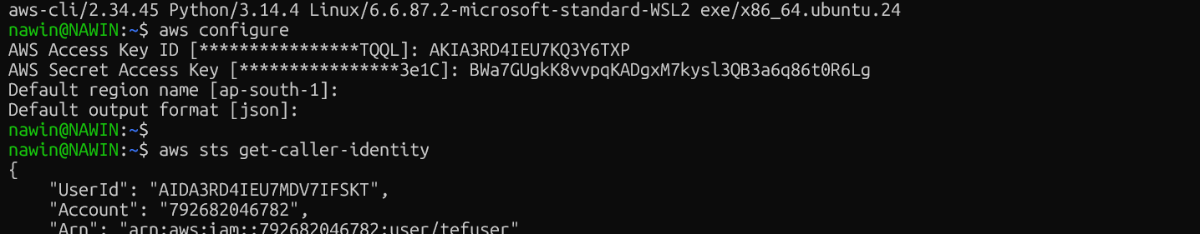

Create Terraform Project
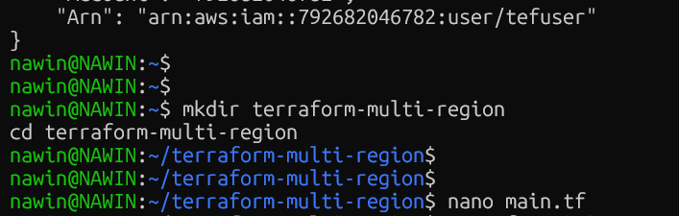

Initiate and complete the terraform script
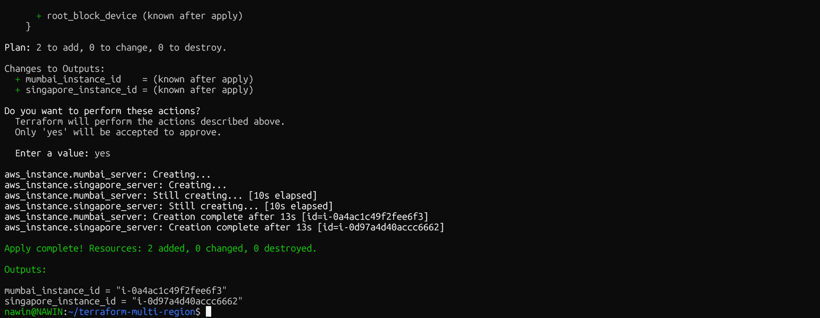

INSTANCE STATUS IN AWS CONSOLE

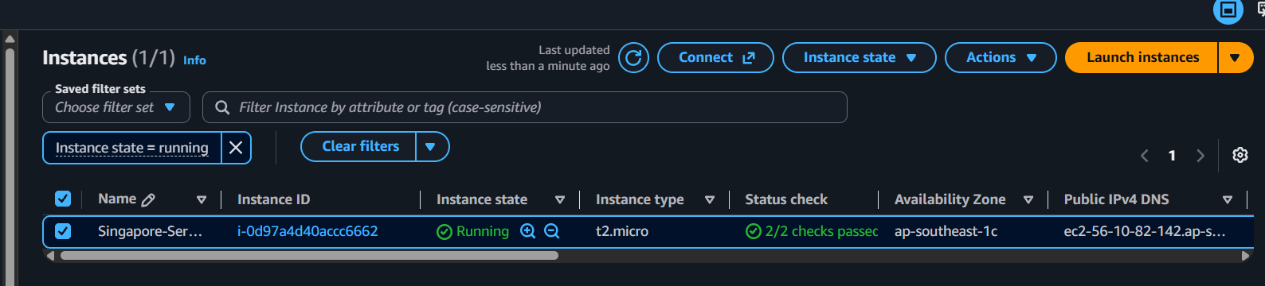

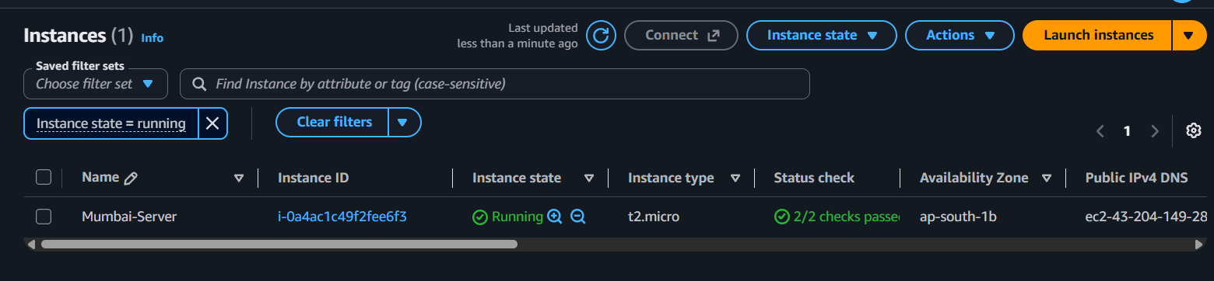+9

